Section A

- Choose the correct words from the box to complete the sentences.

compound mixture hydrocarbons mud plankton rocks finite infinite

Crude oil is a _________________ resource found deep underground. It is made from the biomass of ancient _________________, which was buried under ______________.

- Choose the correct definition of a hydrocarbon.
Tick ( ) one box.
- A compound made of hydrogen and carbon atoms | 
- A compound made of water and carbon atoms
- A mixture made of hydrogen and carbon atoms
- A mixture made of water and carbon atoms

- State the general formula of the alkanes.

__________________________________________________________________________________________

- Choose the name of the alkane that contains three carbon atoms.
Tick ( ) one box.
- Ethane
- Propane
- Butane

- Name the alkane shown by the structural formula below.

_______________________________________

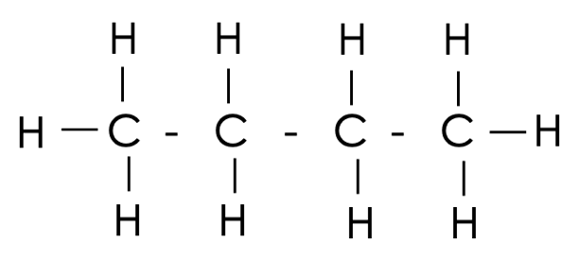

Section B

- Methane and ethane are both alkanes.
- Draw the structural formulae for methane and ethane.

- Complete the dot and cross diagram to show the bonding in a molecule of ethane.

- Compare the structures of methane and ethane.

__________________________________________________________________________________________
__________________________________________________________________________________________
__________________________________________________________________________________________
__________________________________________________________________________________________
__________________________________________________________________________________________

- The alkanes is a large family of compounds.
Determine the chemical formula of an alkane with:
- 8 carbons

_______________________________________

- 24 carbons

_______________________________________

- 36 hydrogens

_______________________________________

- 20 hydrogens

_______________________________________

- The image below shows a model of an alkane.
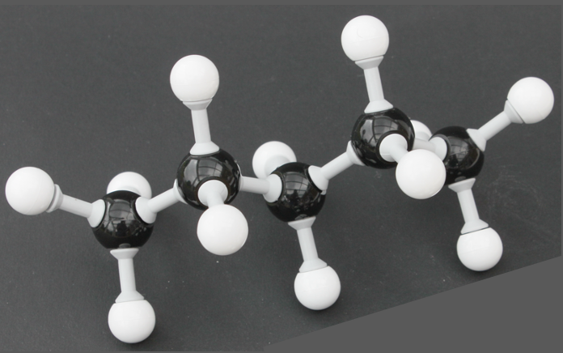

A

- Determine the chemical formula of this alkane.

__________________________________________________________________________________________

- Give an advantage of this model.

__________________________________________________________________________________________
__________________________________________________________________________________________

- What is represented by the letter A?

__________________________________________________________________________________________

- Explain why this alkane is a compound and a molecule.

__________________________________________________________________________________________
__________________________________________________________________________________________
__________________________________________________________________________________________
__________________________________________________________________________________________

Section C

- Carbon has an atomic number of 6 and a mass number of 12.

- State the number of protons, neutrons and electrons in an atom of carbon.
- Draw the electronic configuration of a carbon atom.
- Explain why a carbon atom is neutral.
- Carbon’s mass number is usually rounded to 12 but the relative atomic mass is actually 12.02. Explain why this is not a whole number.
- Compare the atomic structures of carbon-12 and carbon-14.

